The 64-bit VM has issues on my laptop, so was suggested to go ahead with the 32-bit VM. Hence the steps below are for the 32-bit VM.

1. Oracle VM VirtualBox installed. Invoke the same.

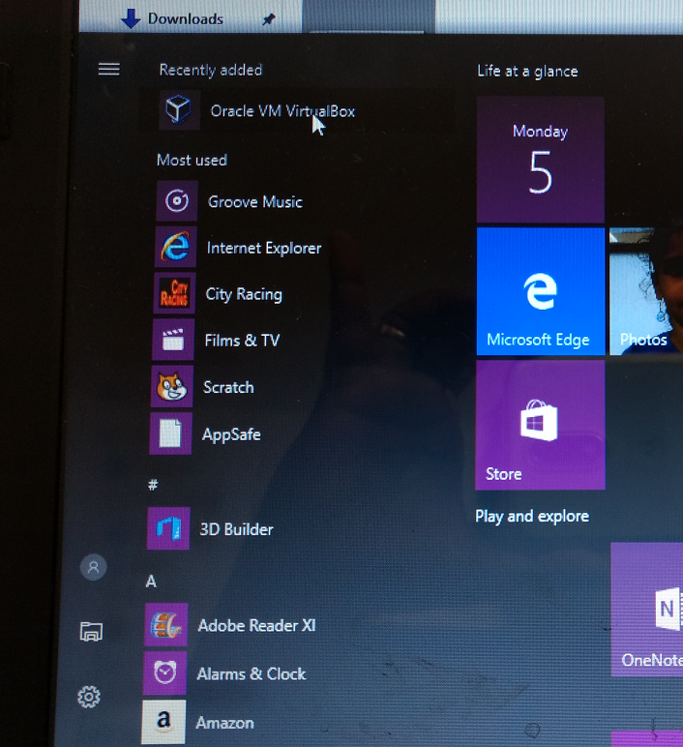

1. Select File->Import

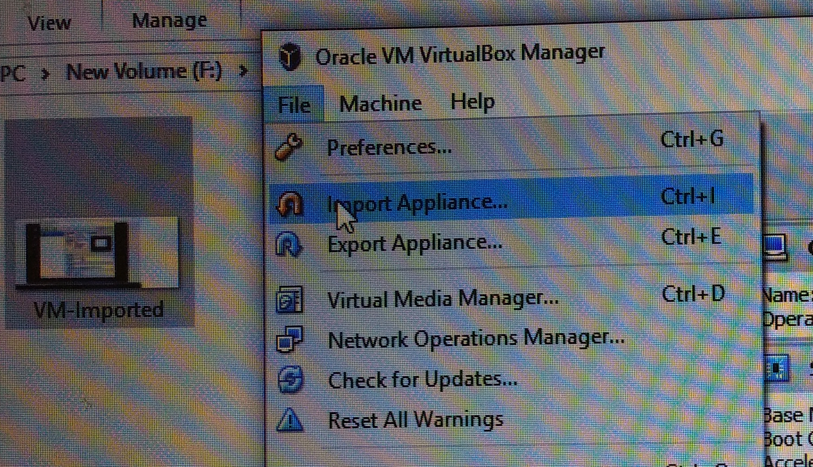

1. Select the downloaded Acadgild VM

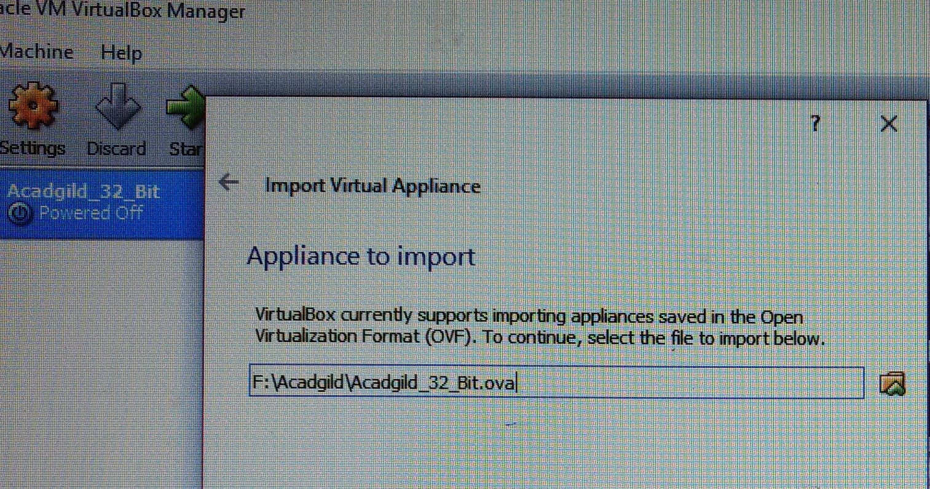

1. After import complete

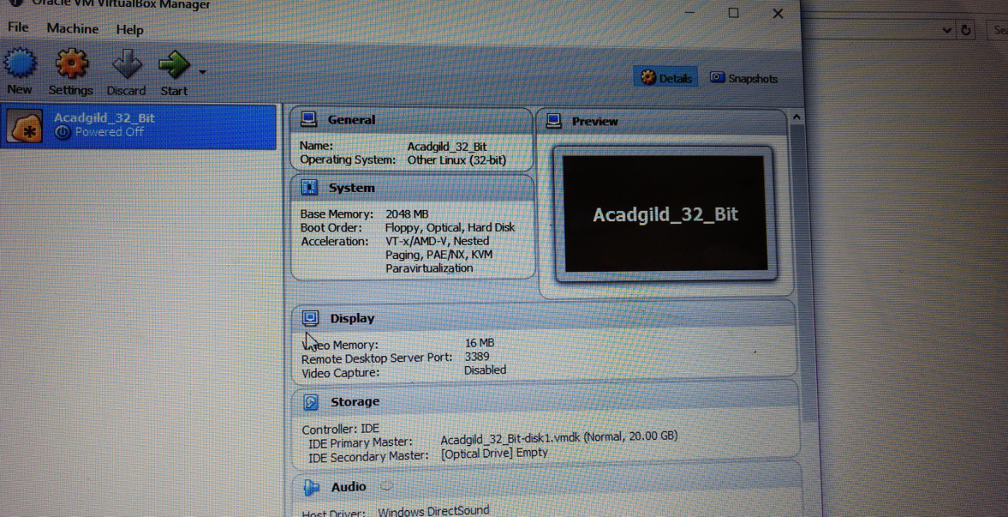

1. After Starting the VM

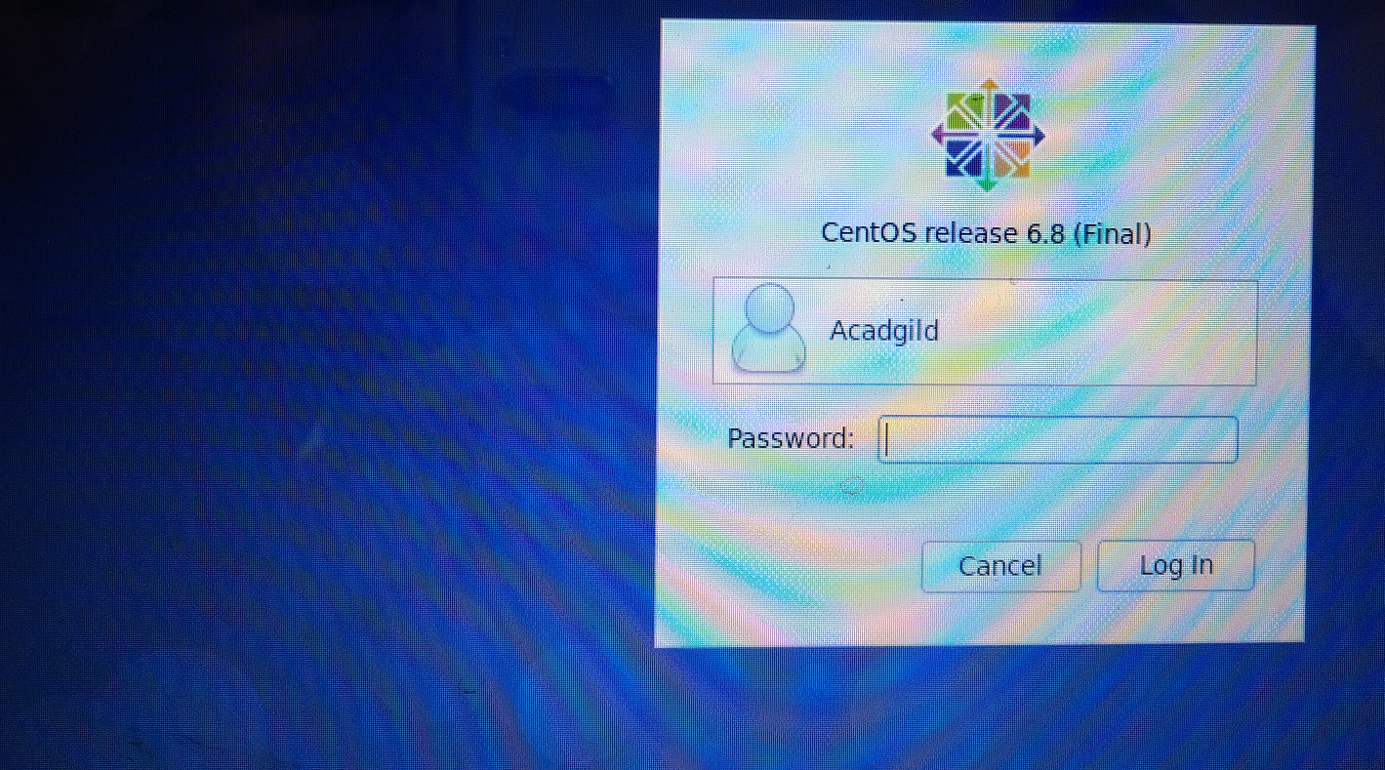

Continuing in Assignment-1-sec2 document.